**Phase 2: Project Execution and Demonstration**

**1. Project Title:**

Intelligent Chatbot Interface using IBM Watson Assistant

**2. Objective Recap:**

The main goal of this project is to build a functional chatbot using IBM Watson Assistant that can interact with users via a simple web-based interface. The bot is capable of processing user queries, maintaining conversation context through session handling, and responding accurately using pre-trained AI models provided by IBM Watson. The chatbot is designed to simulate a basic assistant experience while demonstrating integration of cloud-based NLP services.

**3. Technologies Used:**

* Python (Programming language for backend development)
* Flask (Web framework for creating the chat interface)
* IBM Watson Assistant (V2 API) (Cloud-based AI engine for NLP)
* IBM Cloud IAM (Authentication and access control)
* HTML/CSS & JavaScript (Frontend styling and interactivity)
* Postman (For API testing and validation)

**4. Full Code Implementation:**

**Step 1: Install Required Libraries**

pip install flask ibm-watson ibm-cloud-sdk-core

**Step 2: Import Required Libraries**

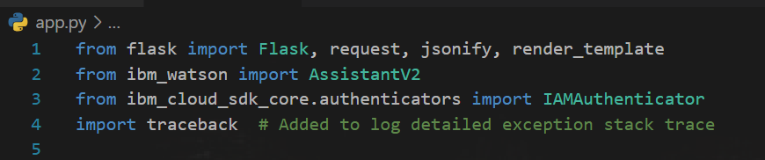

**Step 3: Initialize Watson Assistant**

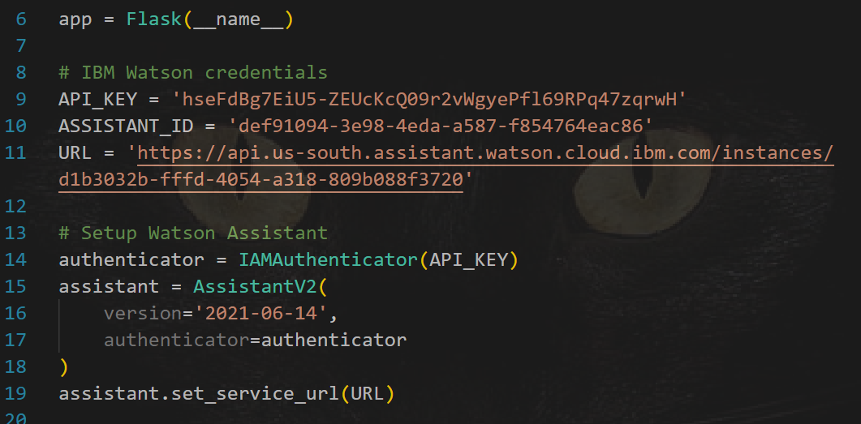

**Step 4: Define Flask Routes**

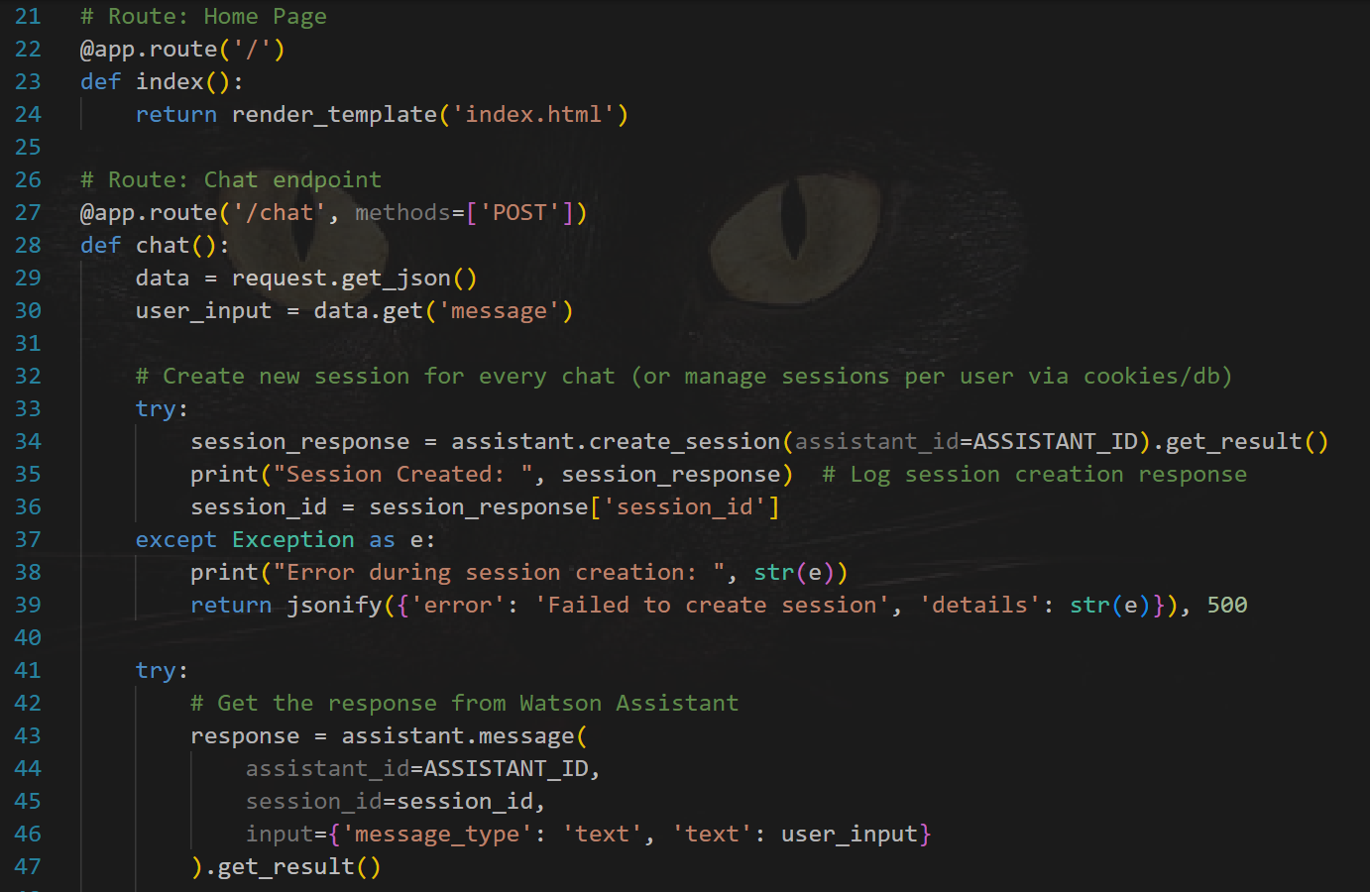

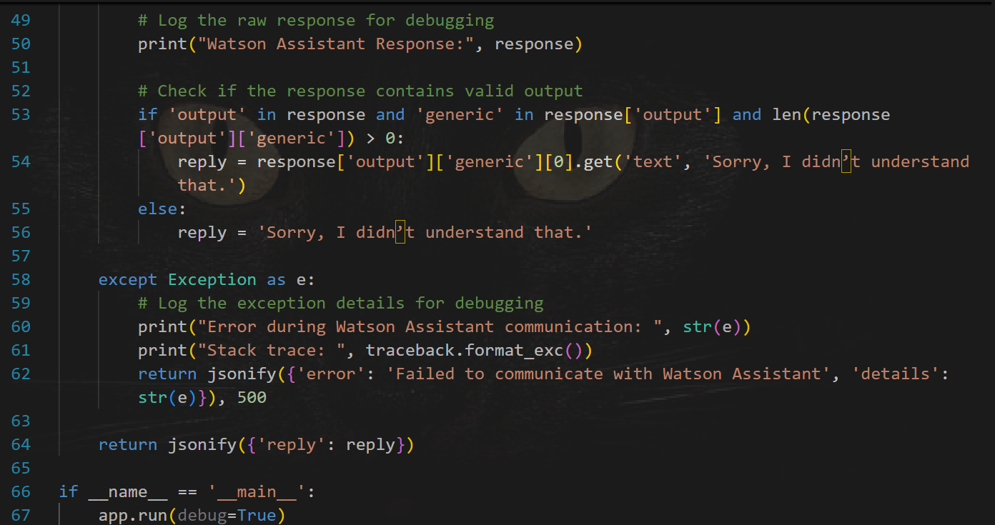

**Step 5: Run the Streamlit App**

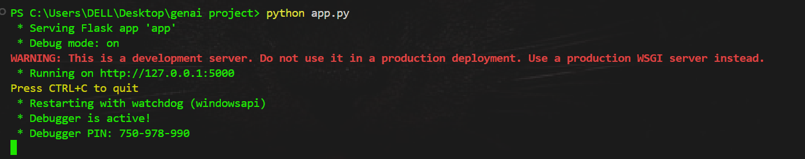

**5. Output Screenshots:**

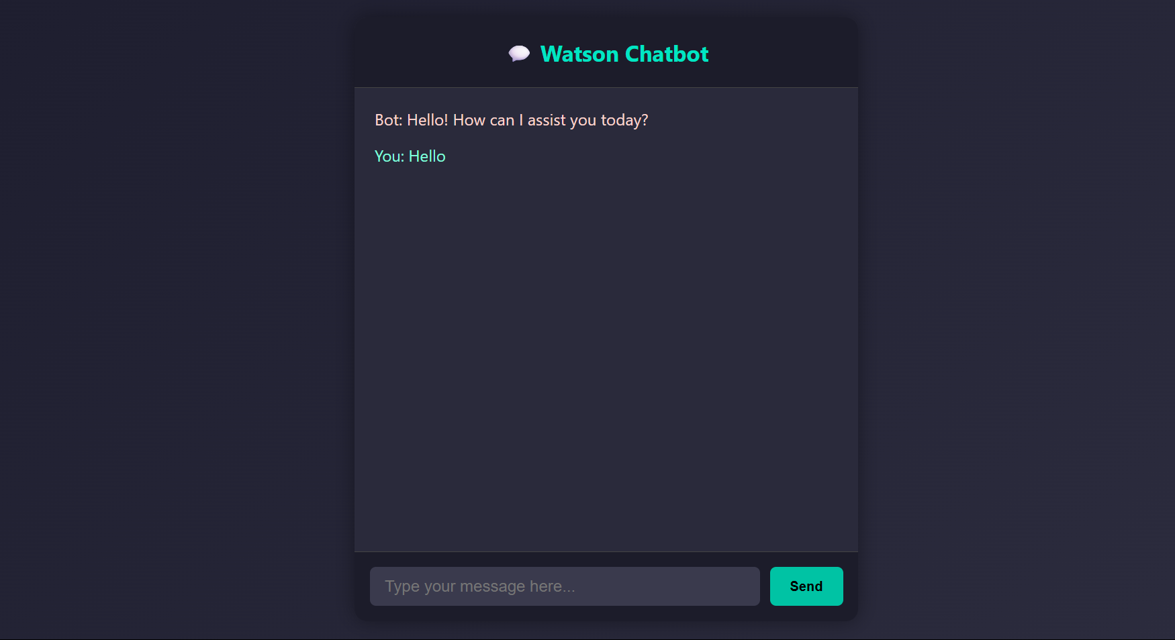

**6. Conclusion:**

The project demonstrates a working chatbot integrated with IBM Watson Assistant, showcasing how cloud-based NLP tools can be used to build intelligent conversational agents. The web interface enables smooth human-bot interaction, while IBM's pre-trained AI ensures quality responses. This chatbot serves as a foundational step toward more advanced AI applications like virtual assistants, customer support bots, and educational interfaces.

**7. References:**

* IBM Watson Assistant V2 API Documentation
* IBM Cloud IAM Authentication Guide
* Flask Web Development Documentation
* Developer discussions on IBM forums and Stack Overflow